THE FOLLOWING DOCUMENT CONTAINS PAINTINGS AND OTHER ART WORK PRODUCED DURING THE NINETEENTH CENTURY. MANY OF THE GRAPHICS ARE CONSIDERED ICONIC. THIS COLLECTION WAS TAKEN FROM VARIOUS INTERNET SITES. FOR MORE INFORMATION, CONSULT THE SEARCH ENGINES AND RESEARCH SPECIFIC ARTISTS OR OTHER NINETEENTH CENTURY IDEAS MENTIONED IN THE TEXTS PROVIDED.
THIS DOCUMENT CONTAINS 25 PAGES OF IMAGES.
Willaim Turner
The Burning of the Houses of Lords and Commons, 16th October, 1834
1835; Oil on canvas, 92 x 123 cm; Philadelphia Museum of Art
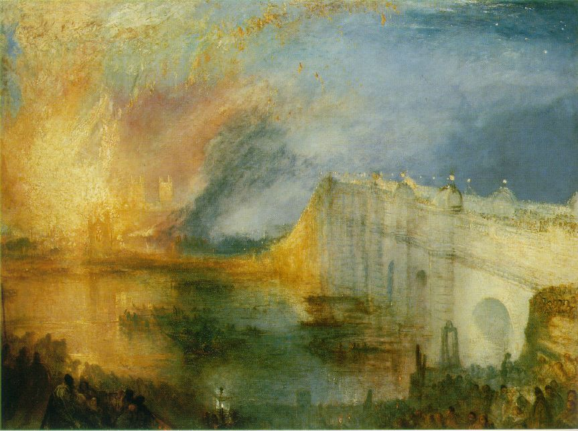

The Fighting "Temeraire" tugged to her last berth to be broken up
1838; Oil on canvas, 91 x 122 cm; National Gallery, London
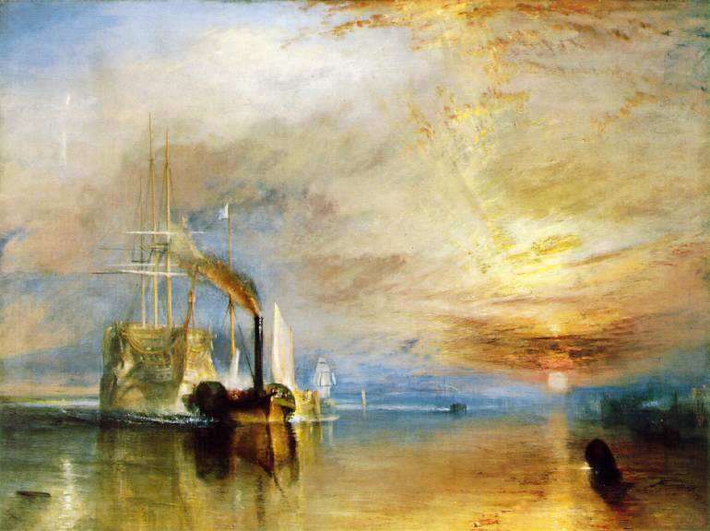
Rain, Steam and Speed
1844; Oil on canvas, 90.8 x 121.9 cm; National Gallery, London 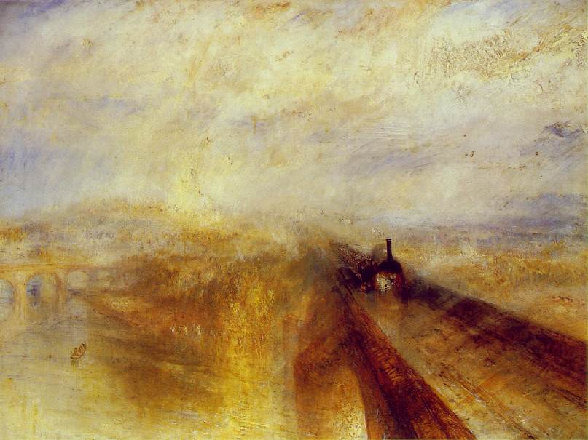

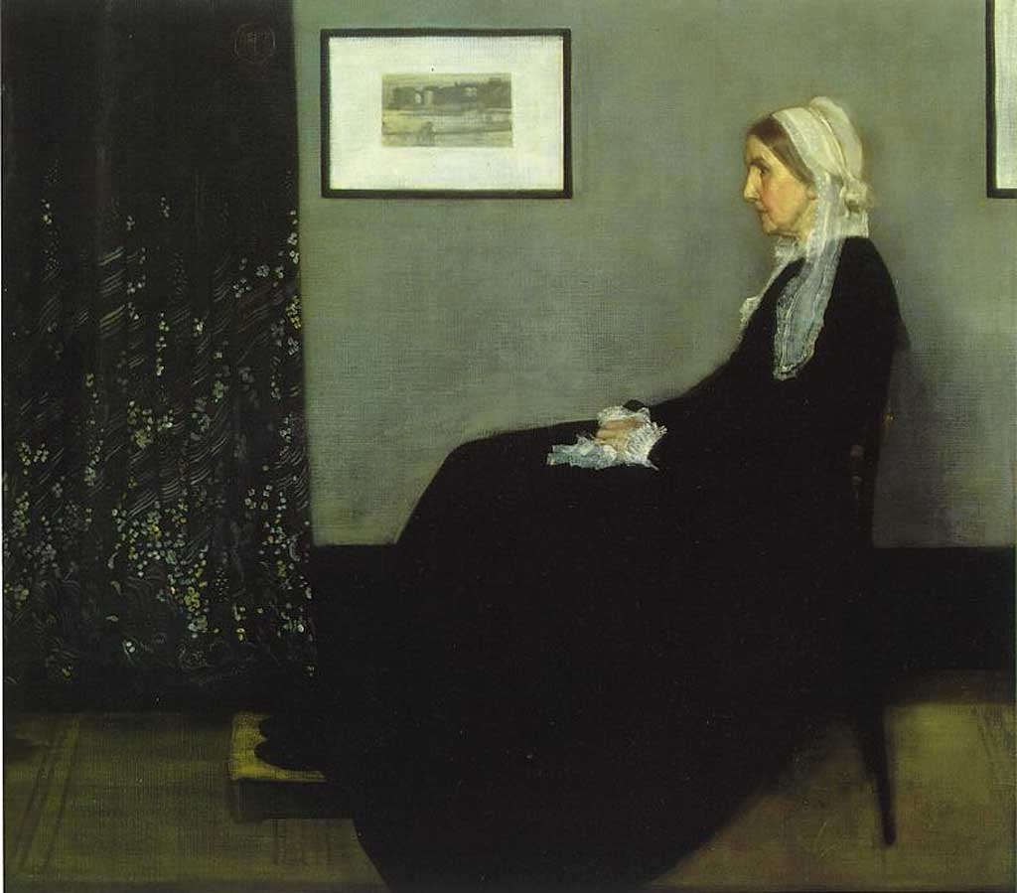 James Abbott McNeill Whistler (July 14, 1834 - July 17, 1903) was an
A native or inhabitant of the United StatesAmerican painter and etcher. He is perhaps best known for his nearly black-and-white full-length portrait of his mother, titled Arrangement in Gray and Black, No. 1, but usually referred to as Whistlers Mother. Though American, Whistler lived and worked mainly in Britain and France. His painting The White Girl (1862) caused controversy when exhibited in London and, later, at the Salon des Refusés in Paris. The painting epitomised Whistler's theory that art should essentially be concerned with the beautiful arrangement of colors in harmony, not with the accurate portrayal of the natural world, as recommended by the critic John RuskinBritish art critic (1819-1900)John Ruskin. In 1878 Whistler sued Ruskin for libel after the critic condemned his painting Nocturne in Black and Gold: The Falling Rocket, calling the artist a "coxcomb". Whistler won afarthing A former British bronze coin worth a quarter of a penny in nominal damages. The cost of the case, together with huge debts from building his residence called the "White House" in Chelsea, bankrupted him.
Whistler was friendly with various French artists, illustrating the book Les Chauves-Souris withAntonio de La GandaraAntonio de La Gandara. He also knew theimpressionists A painter who follows the theories of mpressionism impressionists, notably Edouard Manet French painter whose work influenced the impressionists (1832-1883)Edouard Manet, and was also a leading figure in the Aesthetic Movement. He was well-known for his biting wit, especially in exchanges with his friend Oscar Wilde Irish writer and wit (1854-1900)Oscar Wilde. Both were well-known figures in the café society of Paris The capital and largest city of France; and international center of culture and commerceParis, at the turn of the: 20th century. Whistler's famous riposte to Wilde's statement, "I wish I'd said that" -- "You will Oscar, you will", may be apocryphal.
*** Munch, Edvard

(b. Dec. 12, 1863, Löten, Nor.--d. Jan. 23, 1944, Ekely, near Oslo)
Norwegian painter and printmaker whose intense, evocative treatment of psychological and emotional themes was a major influence on the development of German Expressionism in the early 20th century. His painting The Cry (1893) is regarded as an icon of existential anguish.
A gifted Norwegian painter and printmaker, Edvard Munch not only was his country's greatest artist, but also played a vital role in the development of German expressionism. His work often included the symbolic portrayal of such themes as misery, sickness, and death. The Cry, probably his most familiar painting, is typical in its anguished expression of isolation and fear.
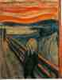The Scream (or The Cry)
1893; 150 Kb; Casein/waxed crayon and tempera on paper (cardboard), 91 x 73.5 cm (35 7/8 x 29"); Nasjonalgalleriet (National Gallery), Oslo
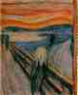The Scream (or The Cry)
180 Kb; Same artwork as above, different photograph
Munch was born on Dec. 12, 1863, in Loten, Norway. He grew up in Christiania (now Oslo) and studied art under Christian Krohg, a Norwegian naturalistic painter. Munch's parents, a brother, and a sister died while he was still young, which probably explains the bleakness and pessimism of much of his work. Paintings such as The Sick Child (1886), Vampire (1893-94), and Ashes (1894) show his preoccupation with the darker aspects of life.
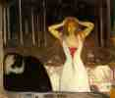Ashes
1894; Oil on canvas, 120.5 x 141 cm; Nasjonalgalleriet (National Gallery), Oslo
Munch traveled to Paris in 1885, and his work began to show the influence of French painters--first, the impressionists, and then the postimpressionists--as well as art nouveau design. Like many young artists Munch reacted against conventional behavior, and in 1892 he took part in a controversial exhibit in Berlin. His circle of friends included several writers, one of whom was the Norwegian playwright Henrik Ibsen. Munch designed the sets for several of Ibsen's plays.
Between 1892 and 1908, Munch spent much of his time in Paris and Berlin, where he became known for his prints--etchings, lithographs, and woodcuts. After 1910 Munch returned to Norway, where he lived and painted until his death. In his later paintings Munch showed more interest in nature, and his work became more colorful and less pessimistic. Munch died in Ekely, near Oslo, on Jan. 23, 1944. He left many of his works to the city of Oslo, which built a museum in his honor.
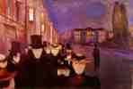Evening on Karl Johan
1892; Oil on canvas, 84.5 x 121 cm; Rasmus Meyer Collection, Bergen
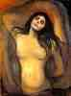Madonna
1894-95; Oil on canvas, 91 x 70.5 cm; National Gallery, Oslo
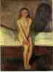Puberty
1895; Oil on canvas, 150 x 110 cm (59 5/8 x 43 1/4 in); Nasjonalgalleriet (National Gallery), Oslo
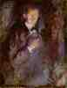Self-Portrait with Burning Cigarette
1895; Oil on canvas, 110.5 x 85.5 cm; National Gallery, Oslo
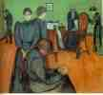Death in the Sickroom
c. 1895; Oil on canvas, 59 x 66 in; National Gallery, Oslo
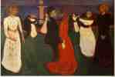The Dance of Life
1899-1900 (120 Kb); Oil on canvas, 49 1/2 x 75 in; National Gallery, Oslo
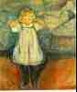The Dead Mother
1899-1900 (130 Kb); Oil on canvas, 39 3/8 x 35 3/8 in; Kunsthalle, Bremen
***

Pre-Raphaelite The Brotherhood Gallery of Art

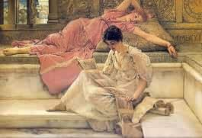
The Favorite Poet by Alma-Tadema

- Wright Barker
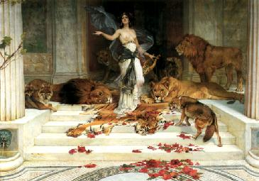
Circe by Wright Barker

- Ford Madox Brown

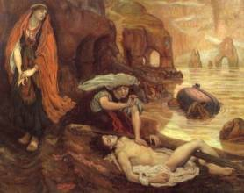
The Finding of Don Juan by Haidee by Ford Madox Brown

- Sir Edward Burne-Jones

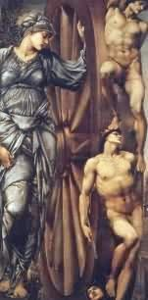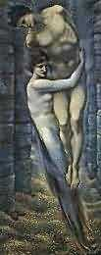
- Wheel of Fortune by Burne-Jones
- Depths of the Sea by Burne-Jones

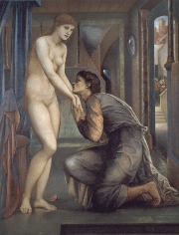
The Soul Attains
(from the Pygmalian series) by Burne-Jones.
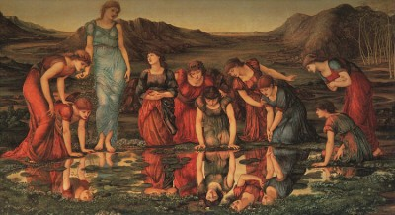
The Mirror of Venus by Sir Edward Burne-Jones

- Hon. John Collier
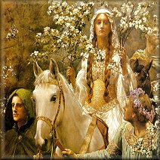
Detail from Guinivere A-Maying by John Collier

- Charles Allston Collins

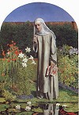Convent Thoughts by Charles Collins
- Frank Cadogan Cowper

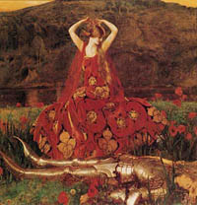
La Belle Dame sans Merci by Frank Cowper

- Jean Delville

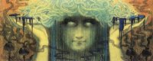
Medusa by Jean Delville

- Sir Frank Dicksee
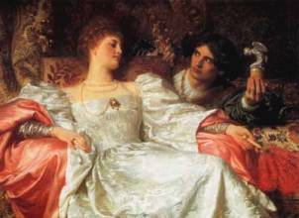
The Offering by Sir Frank Dicksee

- Arthur Hughes

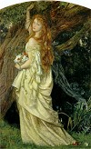
Ophelia and He Will Not Come Again by Arthur Hughes
- William Holman Hunt
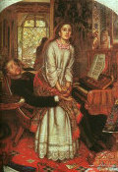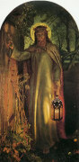
- The Awakening Conscience by Hunt
- The Light of the World by Hunt

- Edmund Blair Leighton
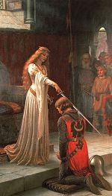
The Accolade by Edmund Blair Leighton
- Frederic Leighton
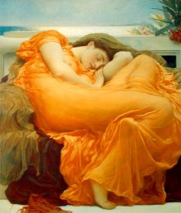
Flaming June by Frederic Leighton

- Charles Rennie Mackintosh/Glasgow School

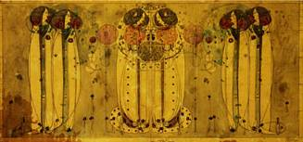
Wassail by Charles Rennie Mackintosh

- Sidney Meteyard .

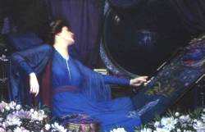
I am Half Sick of Shadows, said the Lady of Shalott
by Sidney Meteyard

- Sir John Everett Millais

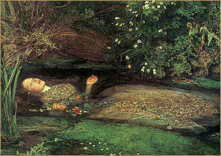
Perhaps the most famous PR painting: Ophelia by John Everett Millais
- William Morris

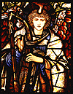
Angel (detail of stained glass window) by William Morris

Dante Gabriel Rossetti
- 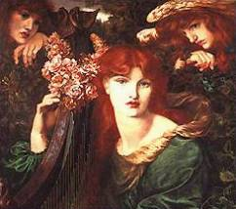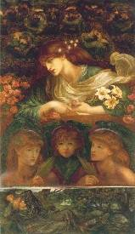

Rossetti, Dante Gabriel
[http://www.ibiblio.org/wm/paint/auth/rossetti/]

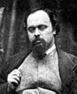The poet, painter, and designer Dante Gabriel Rossetti, b. Gabriel Charles Dante Rossetti, May 12, 1828, d. Apr. 9, 1882, was a cofounder of the PRE-RAPHAELITES, a group of English painters and poets who hoped to bring to their art the richness and purity of the medieval period.
The son of the exiled Italian patriot and scholar Gabriele Rossetti and a brother of the poet Christina Rossetti, Dante showed literary talent early, winning acclaim for his poem The Blessed Damozel (1847) before he was 20 years old. As a student at the Royal Academy Antique School (1845-47), he met William Holman Hunt and John Millais, with whom he launched the Pre-Raphaelite Brotherhood in 1848.
Rossetti's first Pre-Raphaelite paintings in oils, based on religious themes and with elements of mystical symbolism, were The Girlhood of Mary Virgin (1849) and Ecce Ancilla Domini (1850), both in the Tate Gallery, London. Although he won support from John Ruskin, criticism of his paintings caused him to withdraw from public exhibitions and turn to watercolors, which could be sold privately. Subjects taken from Dante Alighieri's Vita Nuova (which Rossetti had translated into English) and Sir Thomas Malory's Morte Darthur inspired his art in the 1850s. His visions of Arthurian romance and medieval design also inspired his new friends of this time, William Morris and Edward Burne-Jones.
Romantic love was Rossetti's main theme in both poetry and painting. Elizabeth Siddal, whom he married in 1860, was the subject of many fine drawings, and his memory of her after she died (1862) is implicit in the Beata Beatrix (1863; Tate Gallery, London). Toward the end of his life, Rossetti sank into a morbid state, possibly induced by his disinterment (1869) of the manuscript poems he had buried with his wife and by savage critical attacks on his poetry. He spent his last years as an invalid recluse.
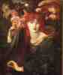La Ghirlandata
(30 Kb); Bridgeman Art Library at London
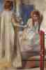Ecce Ancilla Domini (The Annunciation)
1850 (30 Kb)
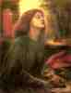Beata Beatrix
1863 (30 Kb); Tate Gallery, London
The death of Beatrice from The Divine Comedy by Dante, the original Italian poet. This painting also reflects Rossetti's greif after the death of his wife, Elisabeth Siddal, the model for Beatrice, painted from memory after her death.
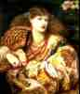Monna Vanna
1866 (30 Kb)
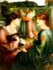The Bower Meadow
1872 (30 Kb)
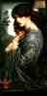Prosperine (Persephone)
1874 (50 Kb)

- Anthony Frederick Sandys

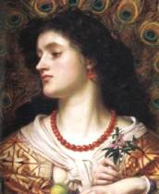
Vivien by Anthony Frederick Sandys

- Simeon Solomon

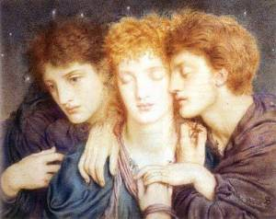
The Sleepers, and the One that Watcheth by Simeon Solomon

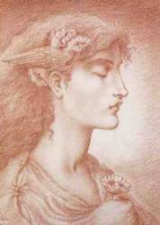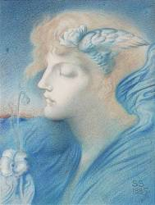
- The Sleeper by Simeon Solomon
- Angel of Light by Simeon Solomon

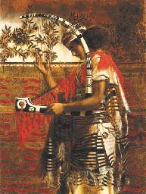
The Musician by Simeon Solomon
(Alternate title: Hosannah)

- John Melhuish Strudwick

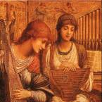
Gentle Music of a Bygone Day [detail] by John M. Strudwick

- John William Waterhouse

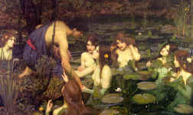
Hylas and the Nymphs by John Waterhouse

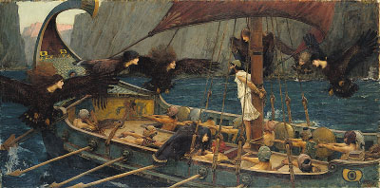
Ulysses and the Sirens by John Waterhouse

- George Frederick Watts
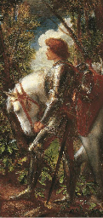
Galahad by George Frederick Watts

- Aubrey Beardsley
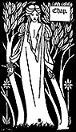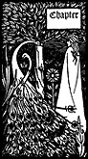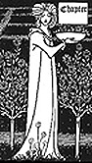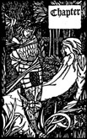
Chapter designs by Aubrey Beardsley

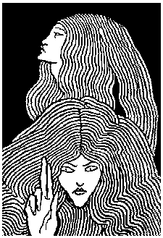
King Arthur illustration by Beardsley
- Walter Crane

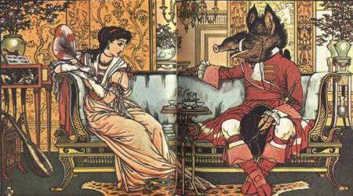
Beauty and the Beast by Walter Crane

- Kay Nielsen

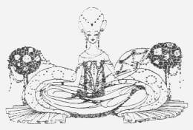
Illustration by Kay Nielsen
- Arthur Rackham

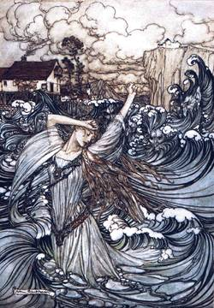
Undine by Arthur Rackham

- Elihu Vedder
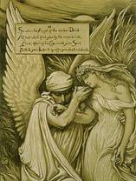
Cup of Death by Elihu Vedder
So when the Angel of the darker Drink
At last shall find you by the river-brink,
And, offering his Cup, invite your Soul
Forth to your Lips to quaff -- you shall not shrink.
Fitzgerald'sRubáiyát of Omar Khayyám

